Module 4 – IICS

IICS SCD1

Source Table

**Create table** [TE_FA_Hrishikesh_Health_IICS] (

[PID] **float**,

[AGE] **float**,

[GENDER] **nvarchar**(25),

[CATEGORY_NAME] **nvarchar**(25),

[DISTRICT_NAME] **nvarchar**(25),

[PREAUTH_AMT] **float**,

[CLAIM_AMOUNT] **float**,

[HOSP_NAME] **nvarchar**(25),

[SURGERY_DATE] **datetime**,

[DISCHARGE_DATE] **datetime**

);

**SELECT** * **FROM** [TE_FA_Hrishikesh_Health_IICS]

**Target Table**

**CREATE** **TABLE** [TE_FA_Hrishikesh_Health_IICS_Target] (

D_PID **float**,

D_AGE **float**,

D_GENDER **nvarchar**(25),

D_CATEGORY_NAME **nvarchar**(25),

D_DISTRICT_NAME **nvarchar**(25),

D_PREAUTH_AMT **float**,

D_CLAIM_AMOUNT **float**,

D_HOSP_NAME **nvarchar**(25),

D_SURGERY_DATE **datetime**,

D_DISCHARGE_DATE **datetime**,

D_PATIENT_KEY **FLOAT**,

D_CHECKSUM **VARCHAR**(25)

);

**SELECT** * **FROM** [TE_FA_Hrishikesh_Health_IICS_Target]];

**SELECT** D_PID, D_CATEGORY_NAME,D_PREAUTH_AMT,D_CLAIM_AMOUNT,

D_HOSP_NAME, D_PATIENT_KEY,D_CHECKSUM **FROM** [TE_FA_Hrishikesh_Health_IICS_Target]

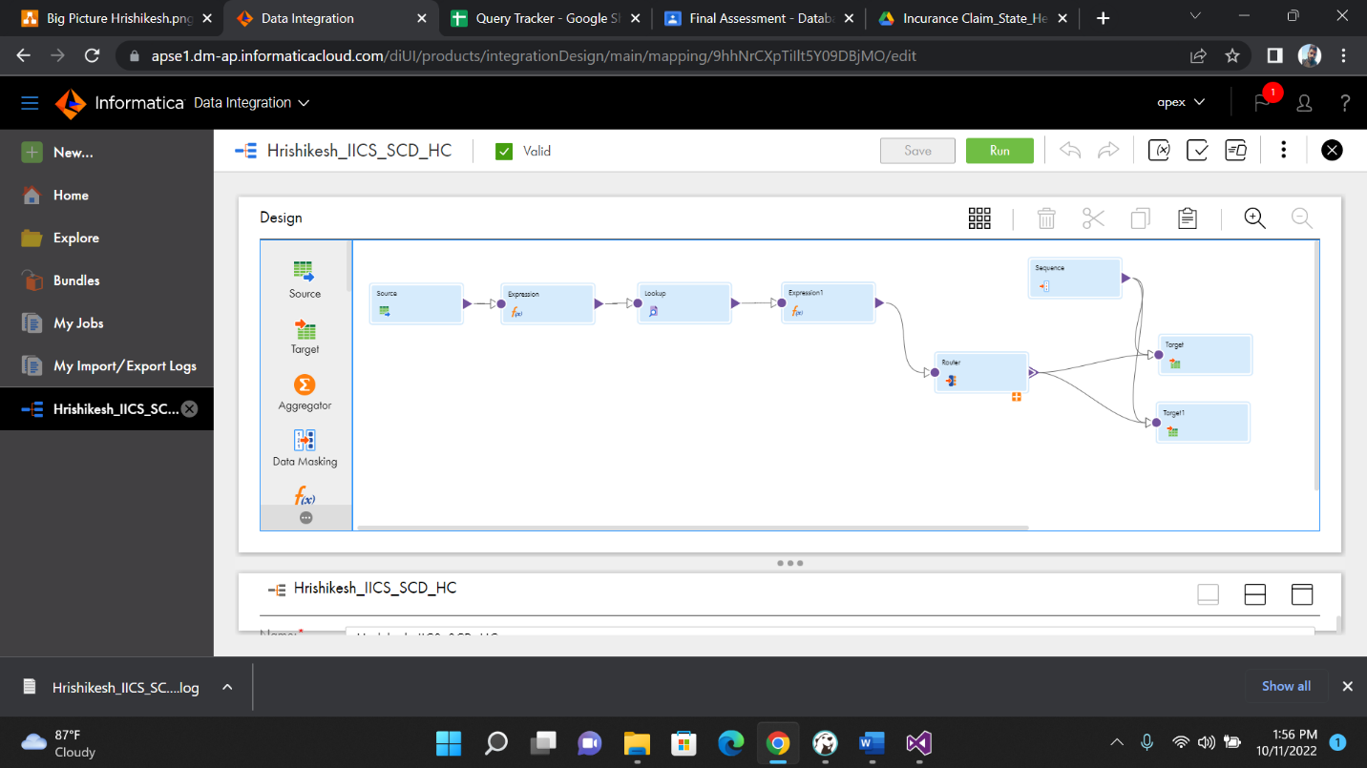

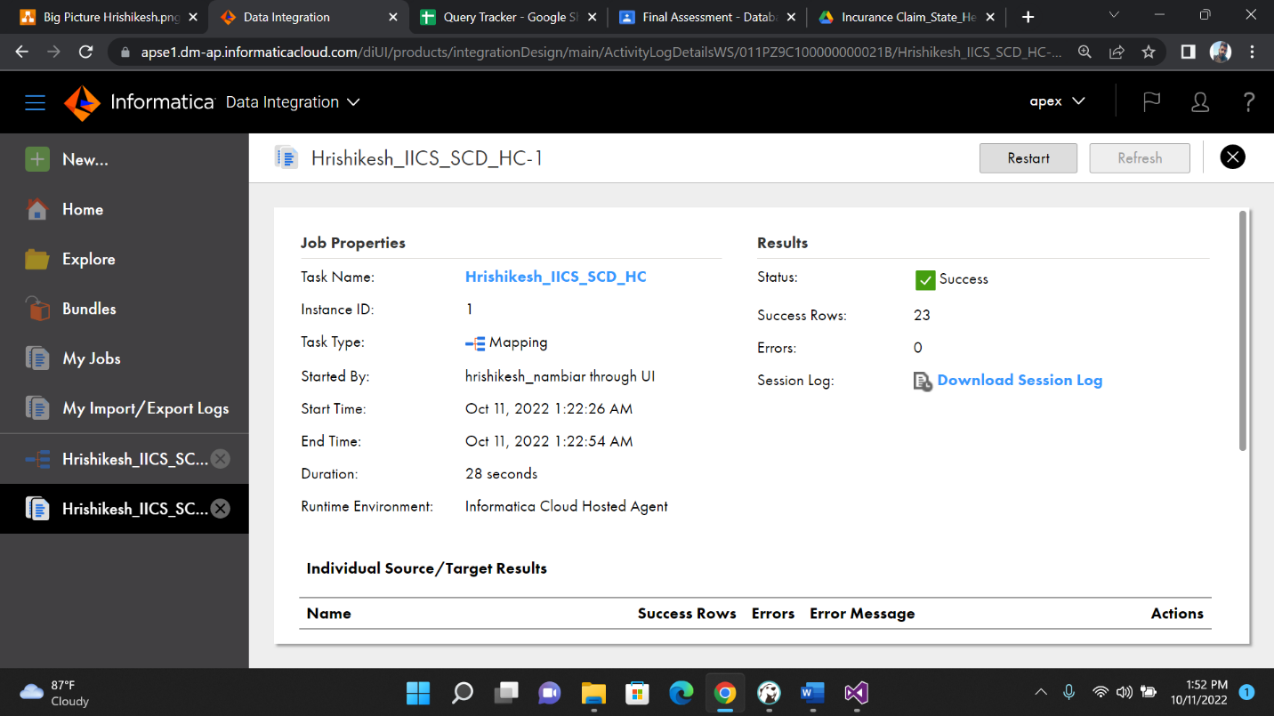

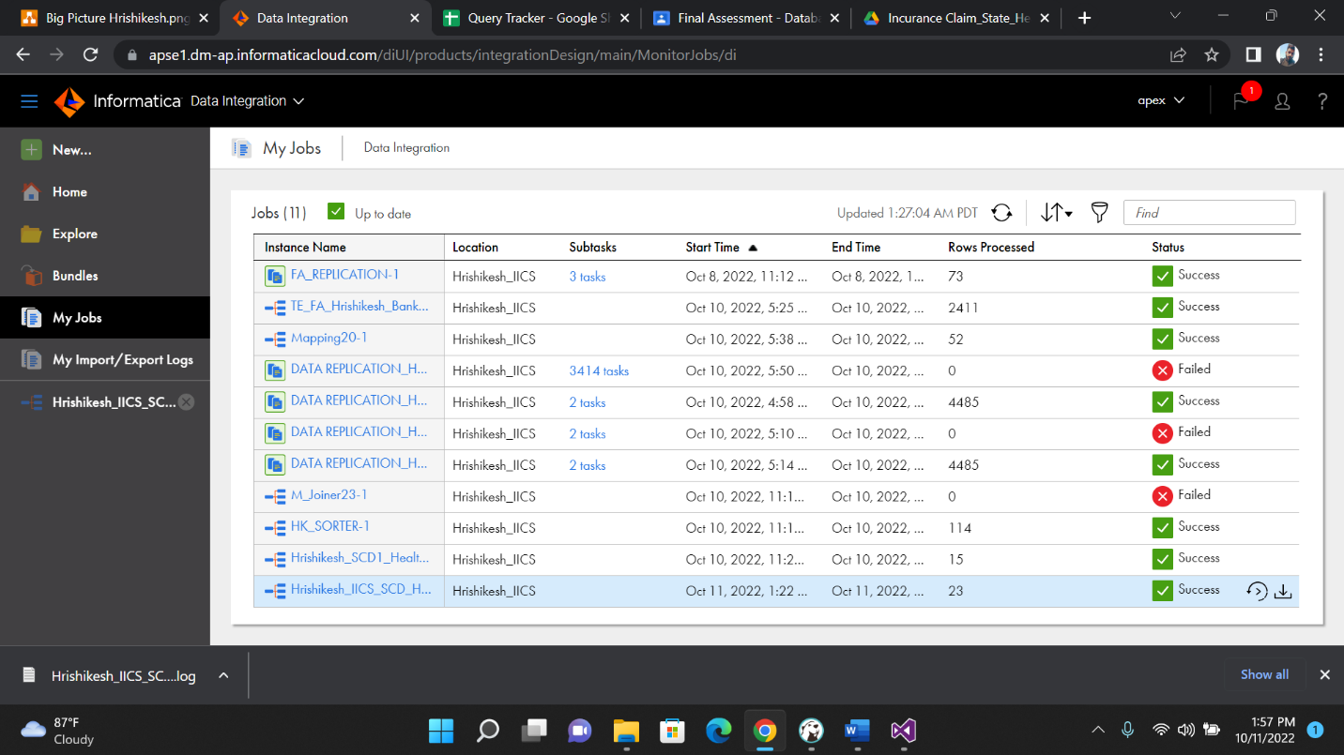

Output

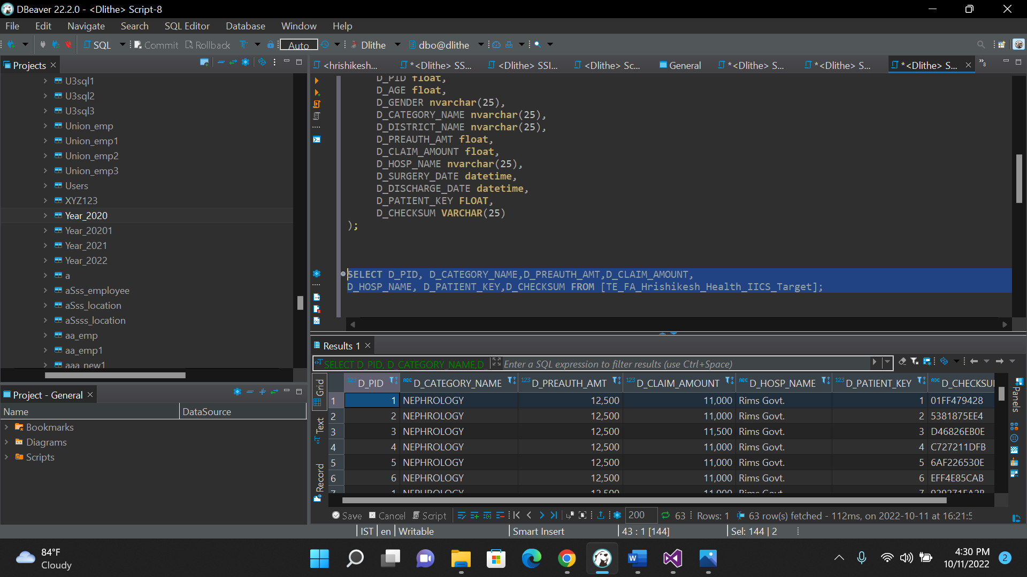

**Update**

**UPDATE** [TE_FA_Hrishikesh_Health_IICS]

**SET** CATEGORY_NAME='ORTHOPEDICS' **WHERE** PID=1;

**SELECT** D_PID, D_CATEGORY_NAME,D_PREAUTH_AMT,D_CLAIM_AMOUNT,

D_HOSP_NAME, D_PATIENT_KEY,D_CHECKSUM **FROM** [TE_FA_Hrishikesh_Health_IICS_Target];

Updated Value Output

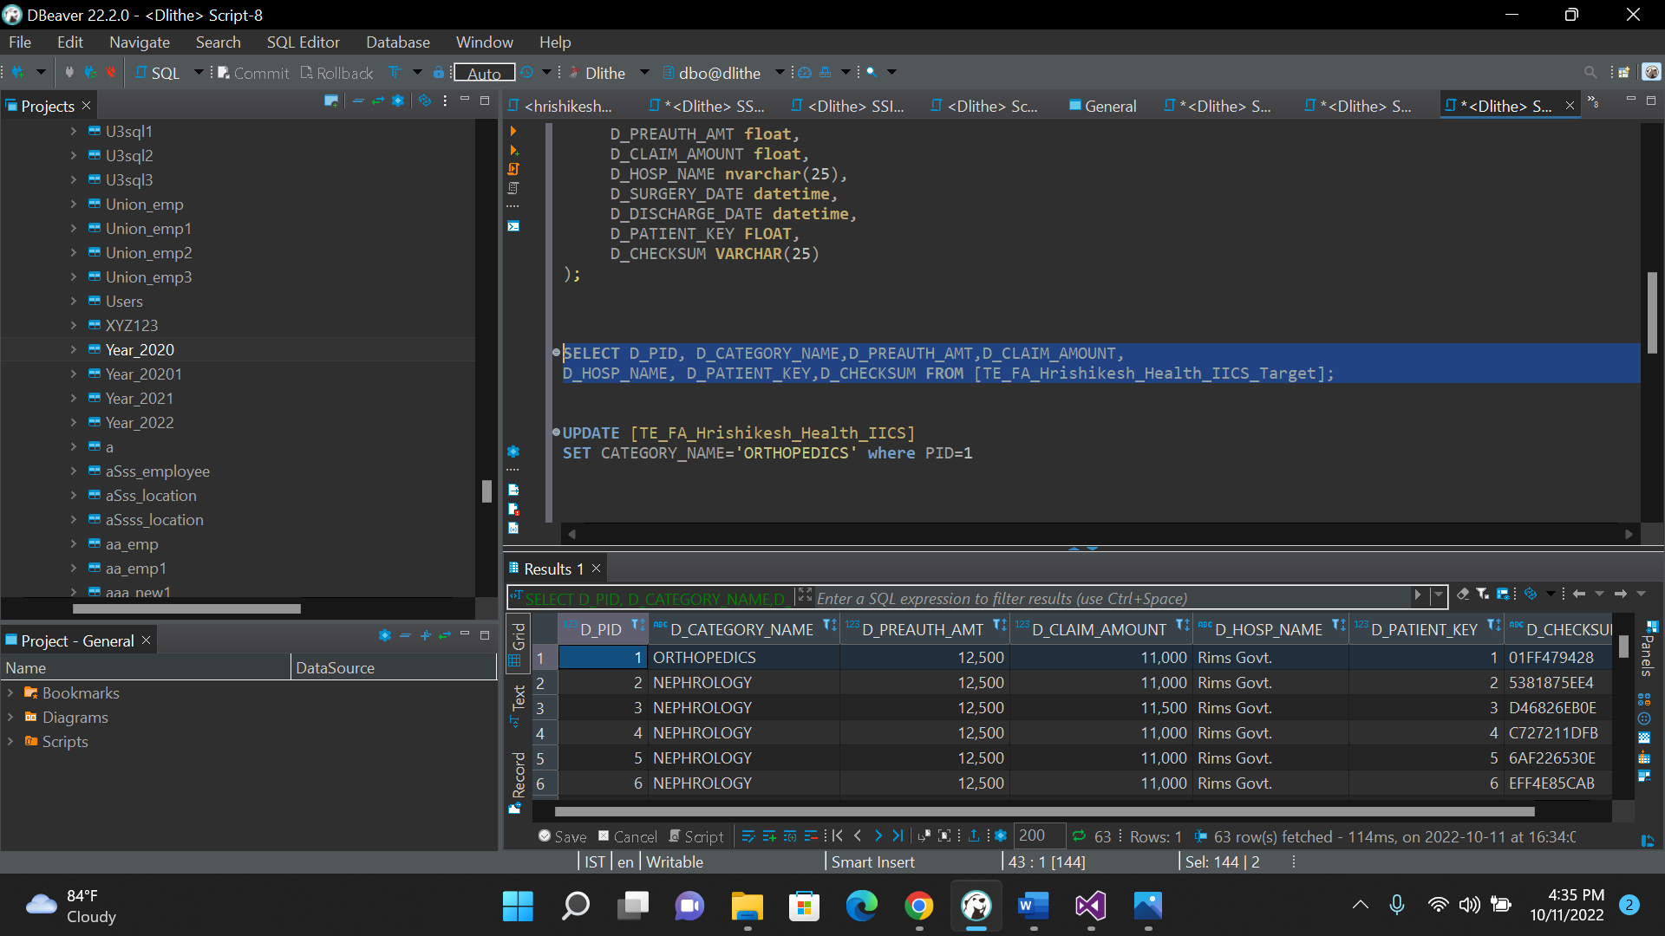

IICS SCD2

Source Table

**CREATE** **TABLE** [TE_FA_Hrishikesh_Health_IICS]

(

[PID] **float**,

[AGE] **float**,

[GENDER] **nvarchar**(25),

[CATEGORY_NAME] **nvarchar**(25),

[DISTRICT_NAME] **nvarchar**(25),

[PREAUTH_AMT] **float**,

[CLAIM_AMOUNT] **float**,

[HOSP_NAME] **nvarchar**(25),

[SURGERY_DATE] **datetime**,

[DISCHARGE_DATE] **datetime**

);

**SELECT** * **FROM** [TE_FA_Hrishikesh_Health_IICS];

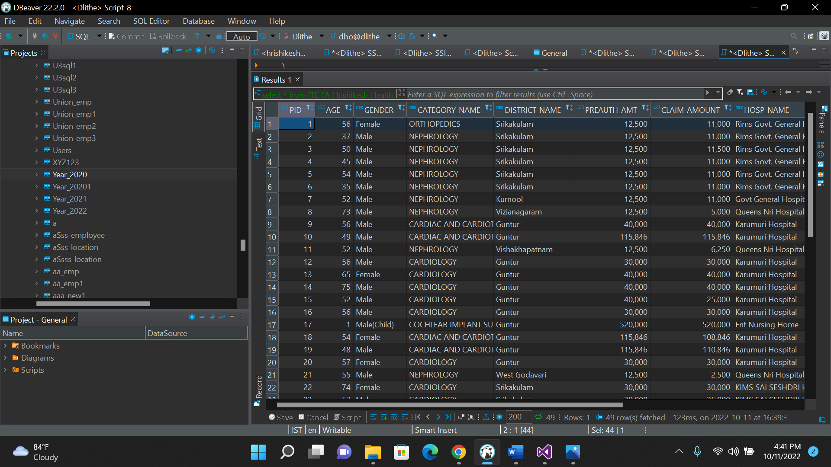

**Target Table**

**CREATE** **TABLE** [TE_FA_Hrishikesh_Health_IICS_Target2] (

D_PID **float**,

D_AGE **float**,

D_GENDER **nvarchar**(25),

D_CATEGORY_NAME **nvarchar**(25),

D_DISTRICT_NAME **nvarchar**(25),

D_PREAUTH_AMT **float**,

D_CLAIM_AMOUNT **float**,

D_HOSP_NAME **nvarchar**(25),

D_SURGERY_DATE **datetime**,

D_DISCHARGE_DATE **datetime**,

D_PATIENT_KEY **FLOAT**,

D_CHECKSUM **VARCHAR**(25)

);

**SELECT** * **FROM** [TE_FA_Hrishikesh_Health_IICS_Target2];

**SELECT** D_PID, D_CATEGORY_NAME,D_PREAUTH_AMT,D_CLAIM_AMOUNT,

D_HOSP_NAME, D_PATIENT_KEY,D_CHECKSUM,D_SURGERY_DATE,

D_DISCHARGE_DATE **FROM** [TE_FA_Hrishikesh_Health_IICS_Target2];

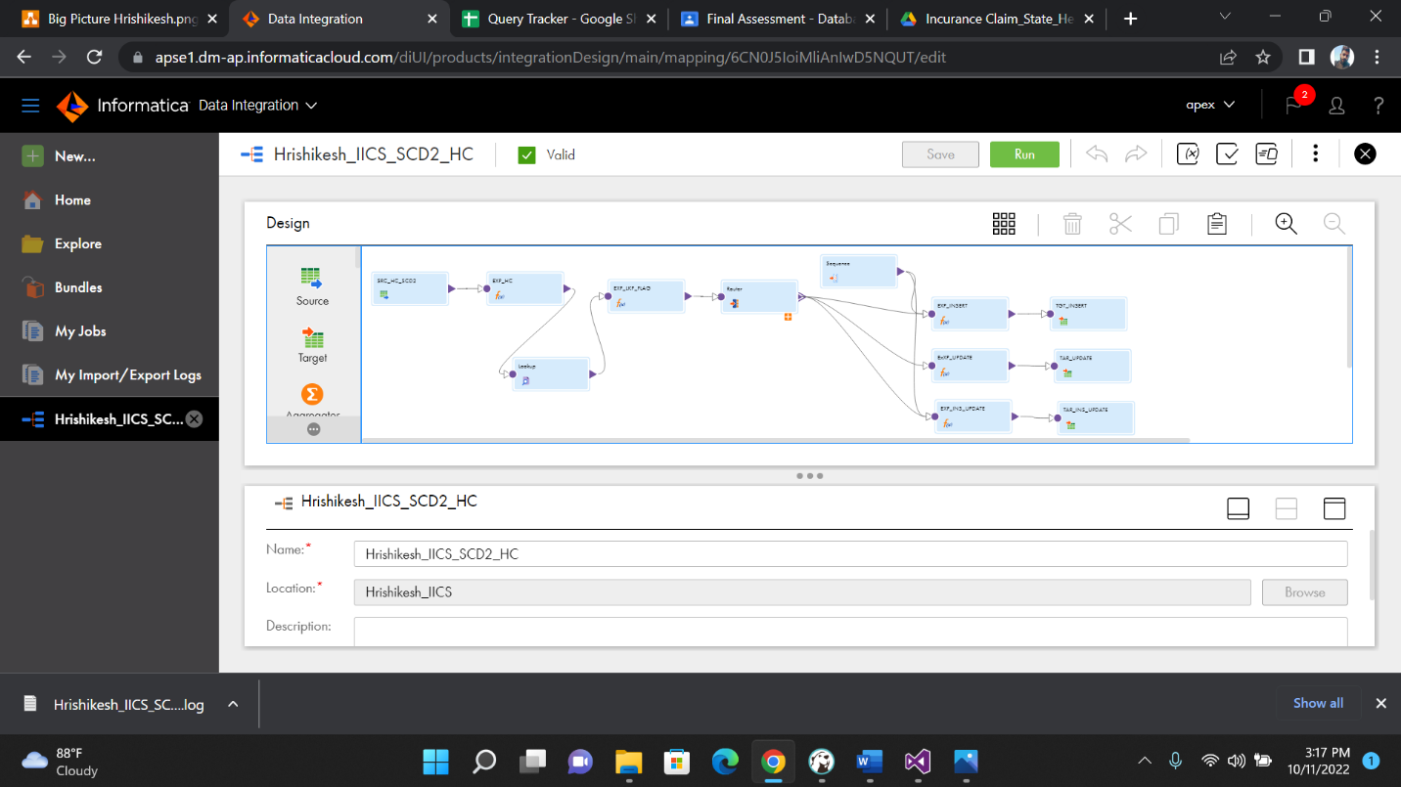

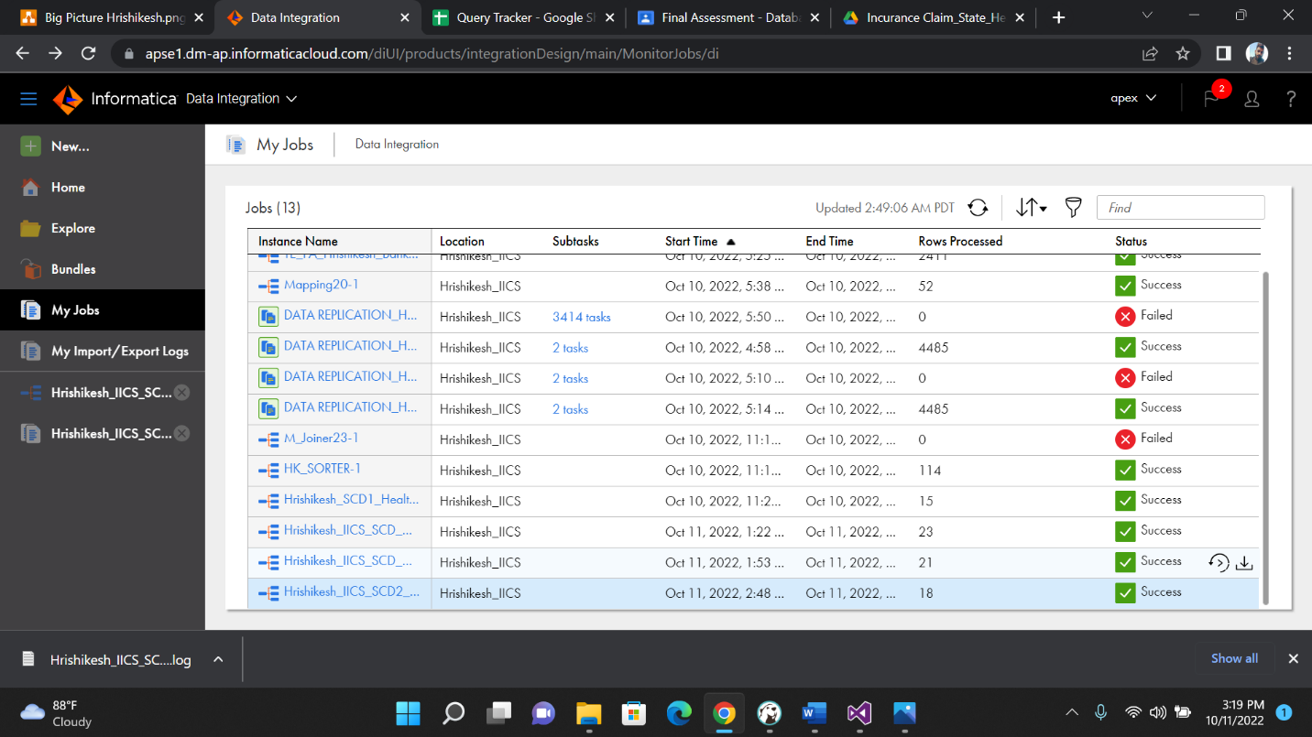

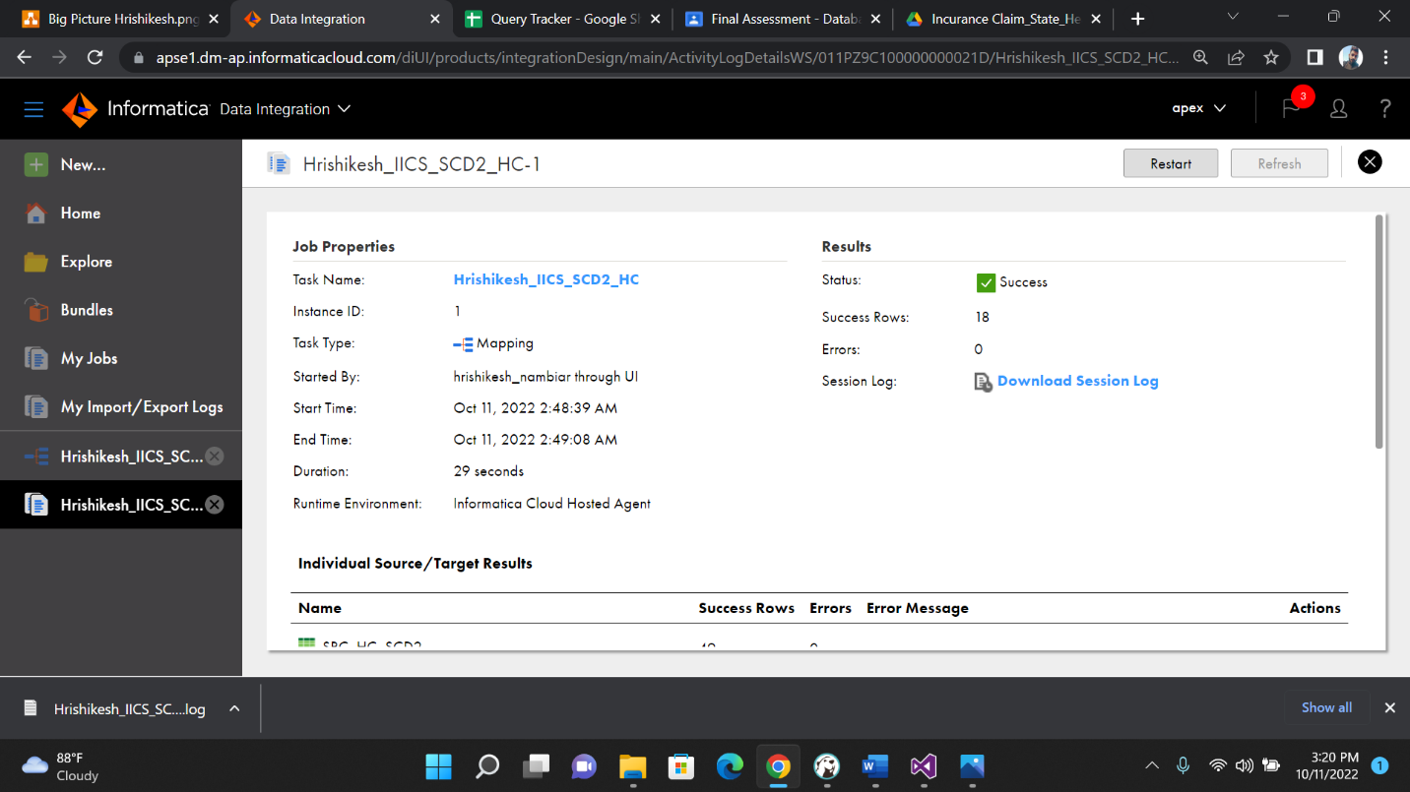

**Output**

**Update**

**UPDATE** [TE_FA_Hrishikesh_Health_IICS]

**SET** CATEGORY_NAME='NEUROLOGY' **WHERE** DISTRICT_NAME='Srikakulam';

**SELECT**\* **FROM** [TE_FA_Hrishikesh_Health_IICS];

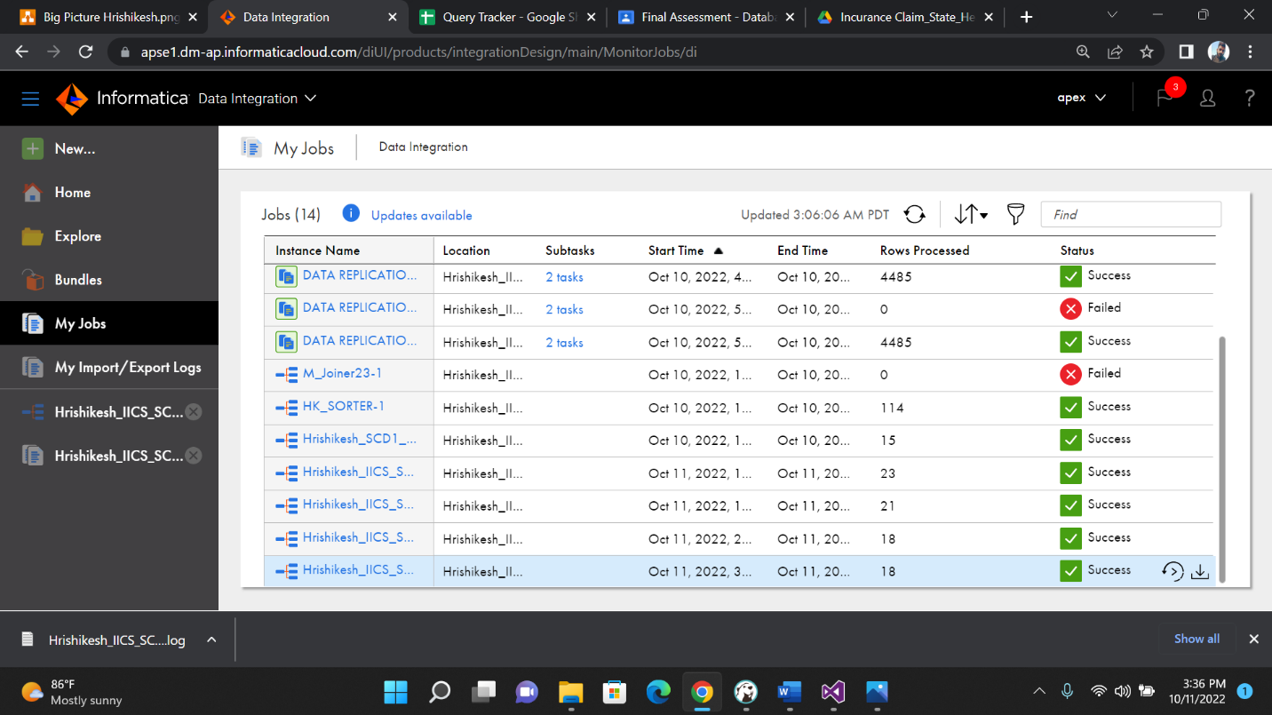

**Updated Value Output**

**SELECT** * **FROM** [TE_FA_Hrishikesh_IICS_Health_Target2];

**SELECT** D_PID, D_CATEGORY_NAME,D_PREAUTH_AMT,D_CLAIM_AMOUNT,

D_HOSP_NAME, D_PATIENT_KEY,D_CHECKSUM,D_SURGERY_DATE,

D_DISCHARGE_DATE **FROM** [TE_FA_Hrishikesh_IICS_Health_Target2];

-We will get an historical data in TE_FA_Hrishikesh_IICS_Health_Target2

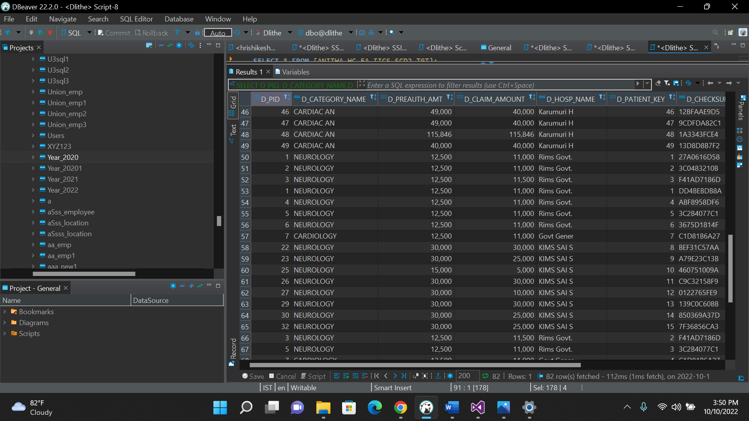

AGGREGATE FUNCTION

**Create table** [TE_FA_Hrishikesh_Health_IICS] (

[PID] **float**,

[AGE] **float**,

[GENDER] **nvarchar**(25),

[CATEGORY_NAME] **nvarchar**(25),

[DISTRICT_NAME] **nvarchar**(25),

[PREAUTH_AMT] **float**,

[CLAIM_AMOUNT] **float**,

[HOSP_NAME] **nvarchar**(25),

[SURGERY_DATE] **datetime**,

[DISCHARGE_DATE] **datetime**

);

**SELECT** * **FROM** [TE_FA_Hrishikesh_Health_IICS];

Target Table

**CREATE** **TABLE** [TE_FA_Hrishikesh_IICS_Health_Aggregate_Target] (

[PID] **float**,

[AGE] **float**,

[GENDER] **nvarchar**(25),

[CATEGORY_NAME] **nvarchar**(25),

[DISTRICT_NAME] **nvarchar**(25),

[PREAUTH_AMT] **float**,

[CLAIM_AMOUNT] **float**,

[HOSP_NAME] **nvarchar**(25),

[SURGERY_DATE] **datetime**,

[DISCHARGE_DATE] **datetime**

);

**SELECT** * **FROM** [TE_FA_Hrishikesh_IICS_Health_Aggregate_Target];

**Output**

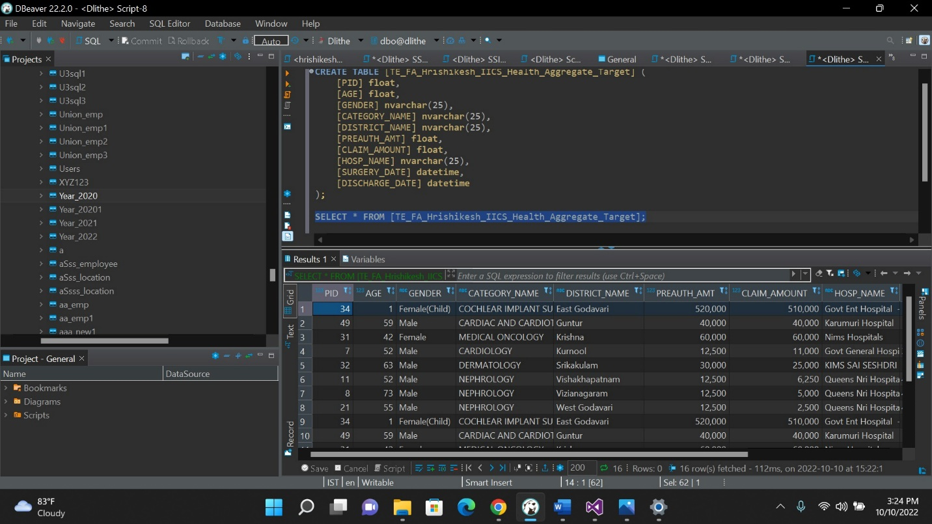

**Replication Task**

**1.Source Connection**

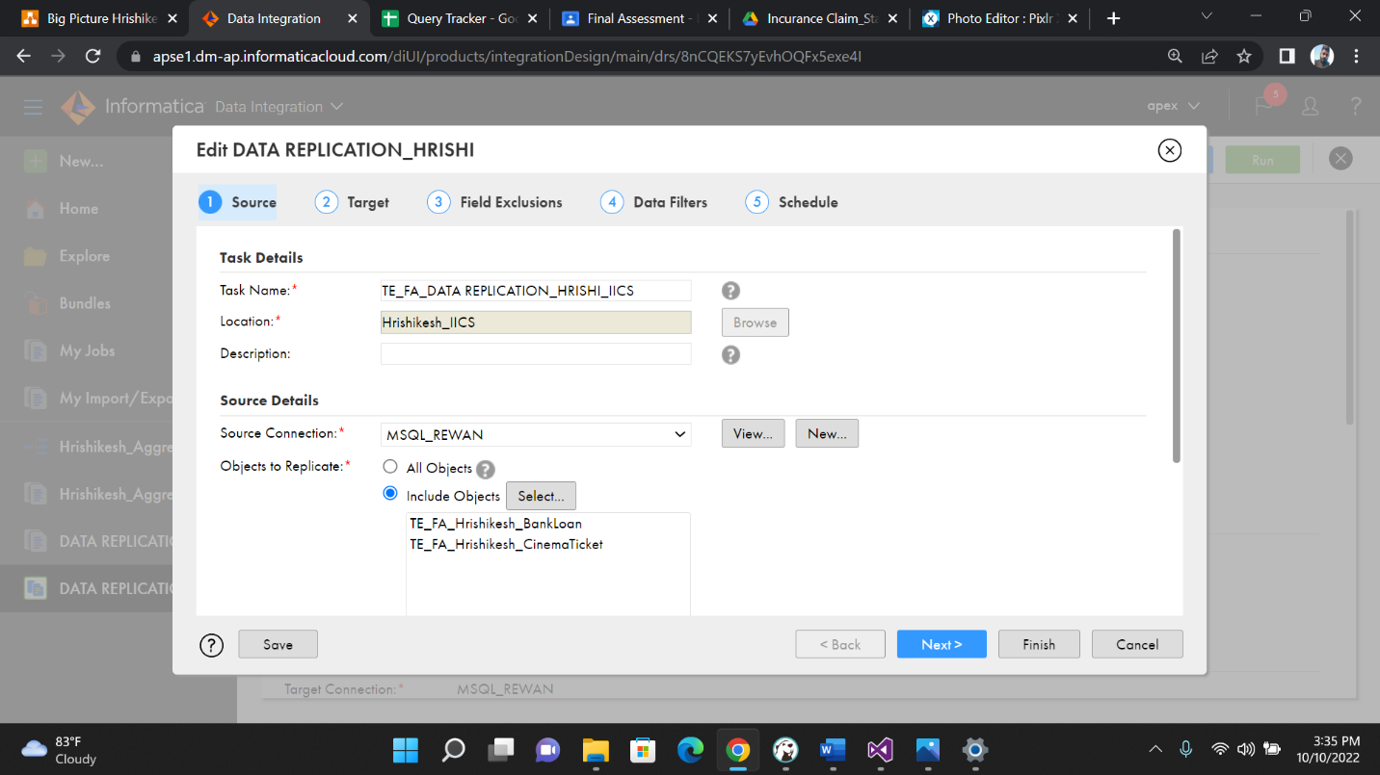

**

**3.Data Filters**

**4.Schedule The Task**

**5.Output of Replication Task**

